Lab 7: Get Loopy
IT 1090C Computer Programming I
IT 6090C Java Programming
Prof. Jason Geanuracos
Fall 2025

Lab 7: Get Loopy
20 points

Directions:
For this lab, you will implement Looping problems. As you work through the tasks, paste a screenshot immediately after the loop description.
Screenshot shortcut keys
- Windows: Alt + printScrn key puts image of desktop in clipboard. Then paste (ctrl+v) it into the document. You can also use Opt (Start) + Shift + s to bring up a cropping tool and paste that into your document. This may be easier. Also, you can hit Start + v to bring up the clipboard if you would like to screenshot multiple pictures and then paste all at once. Mac: Shift + Command + 3 or Shift + Command + 4 to capture a portion of the screen. Then, paste (command + v) it into the document.

To begin:
- Create a project named GetLoopy.
- Create a GitHub repo for your project.
- Make it public until we have graded your work. Submit the link to the repo. You can post link under each screenshot.

Part A: Tasks 1-4, Counting (for) Loops (2 points each)

Instructions
Use for loops. Don’t be clever and use a while loop!
We need to see the code for your loop and its output here!
Use System.out.print(…) instead of printf and spaces or tabs so you don’t print these loops out one number per line.

Task 1
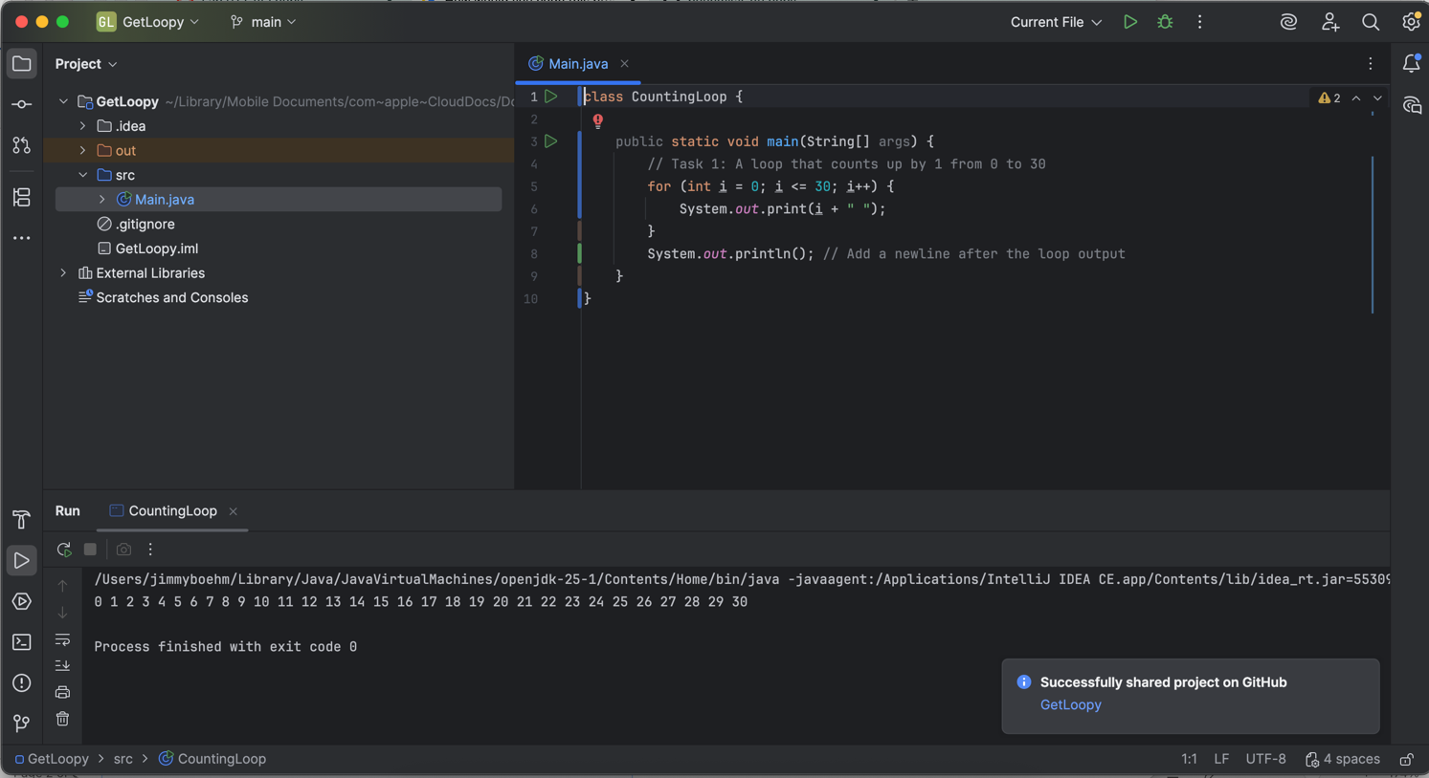
A loop that counts (i.e. displays the count) up by 1 from 0 to 30

Task 2
A loop that counts down by 1 from 30 to 0
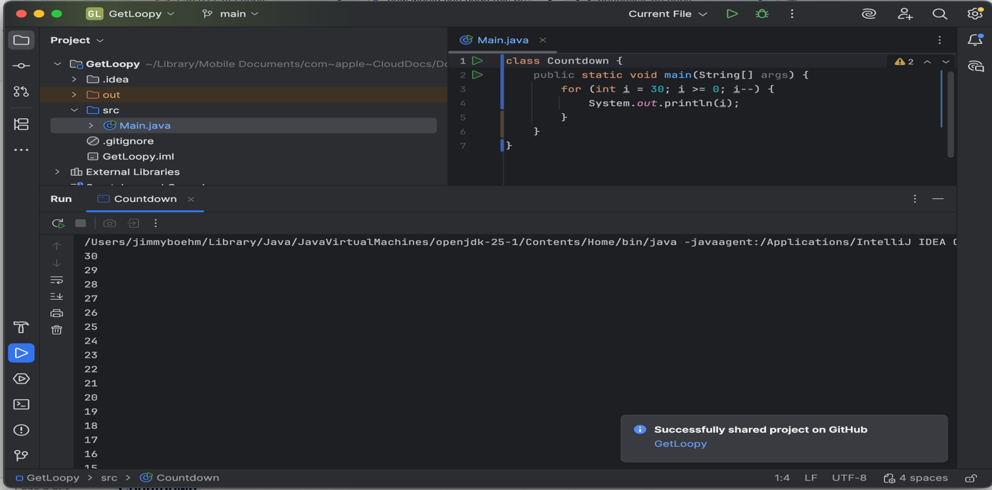

Task 3
A loop that counts up by 3 from 0 to 18
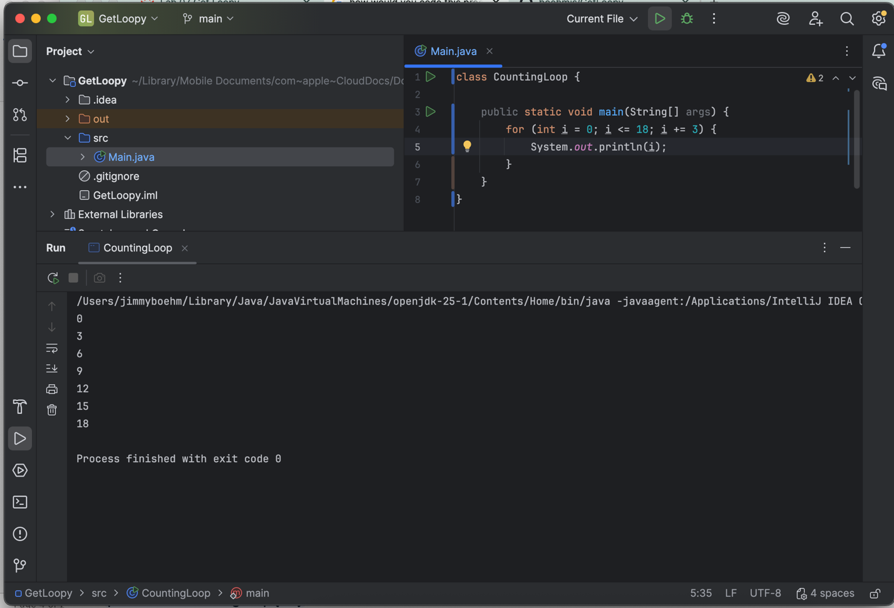

Task 4
A loop that counts down by 2 from 10 to 0
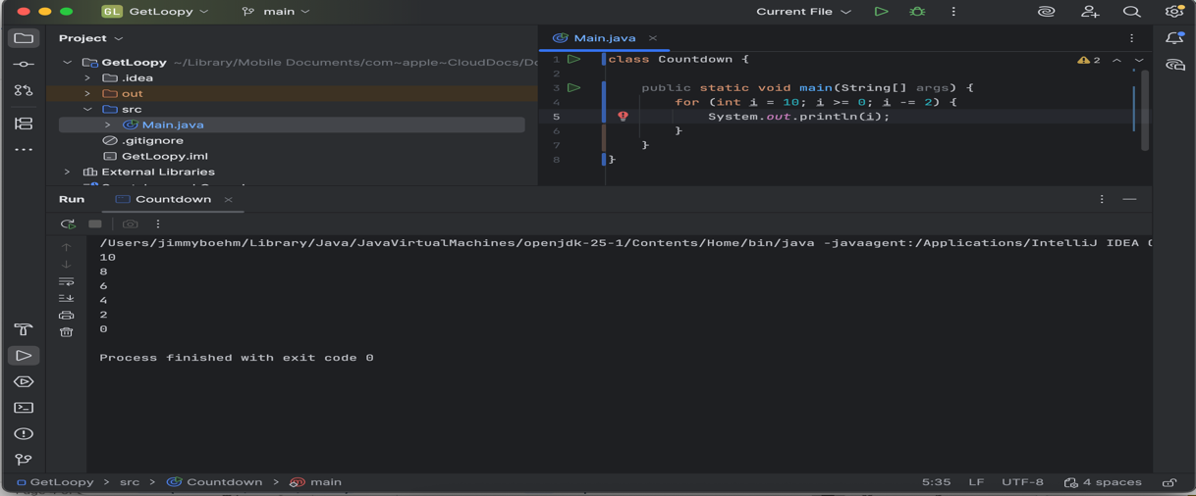

Part B: Tasks 5-7, Output (Nested) for loops (3 points each)

Instructions
Use nested for loops to do these. There are no extra empty lines so each figure is composed of a stack of 5 lines of output
Hint: skip down to Task 7 and do that first. It will help you with the diagonal ones.

Task 5
A nested loop that creates this figure (there are no blank lines)
*
* *
* * *
* * * *
* * * * *
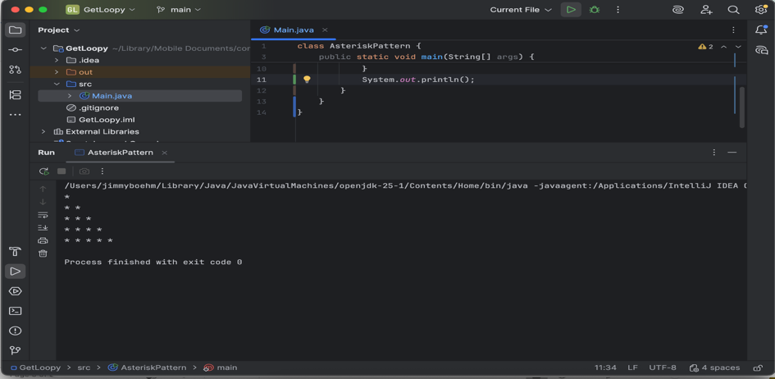

Task 6
A nested loop that creates this figure (there are no blank lines)
* * * * *
* * * *
* * *
* *
*
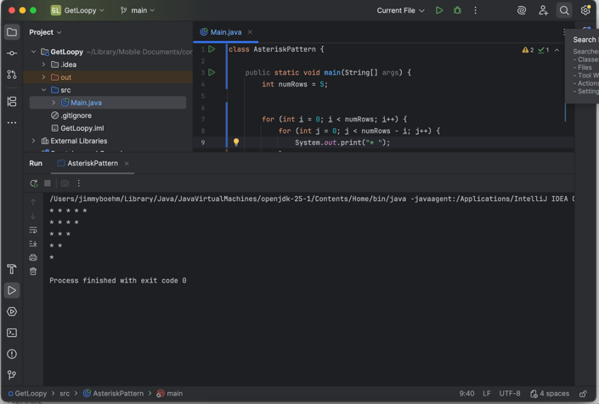

Task 7
A nested loop that creates this square figure (there are no blank lines)
* * * * *
* * * * *
* * * * *
* * * * *
* * * * *
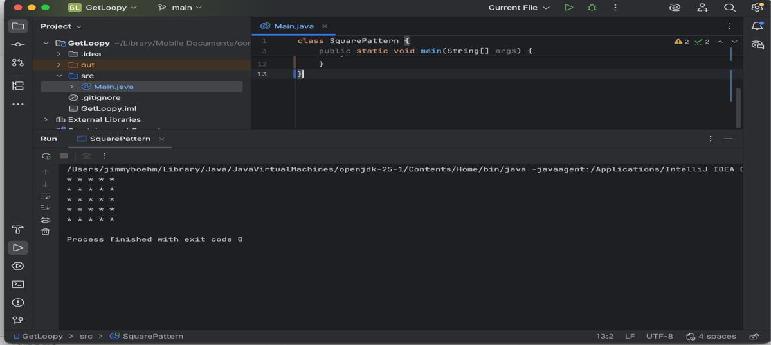

Part C:

Task 8 Die Roller (3 pts)
Within your project create a program named DieRoller. Using java.util Random to generate 3 random values that represent 3 thrown die (1 – 6). Throw until you get a triple (where each die has the same value).
For each throw:
Use ‘printf’ to neatly display in a table for each row:
- the number of each throw 1,2,3…
- the 3 die values,
- the sum of the die
- put a header row and make your table like this:

Roll Die1 Die2 Die3 Sum
----------------------------------------------------------
1 2 4 5 11
2 1 1 1 3

The program should offer to continue until the user quits. Provide 3 screenshots of the output.
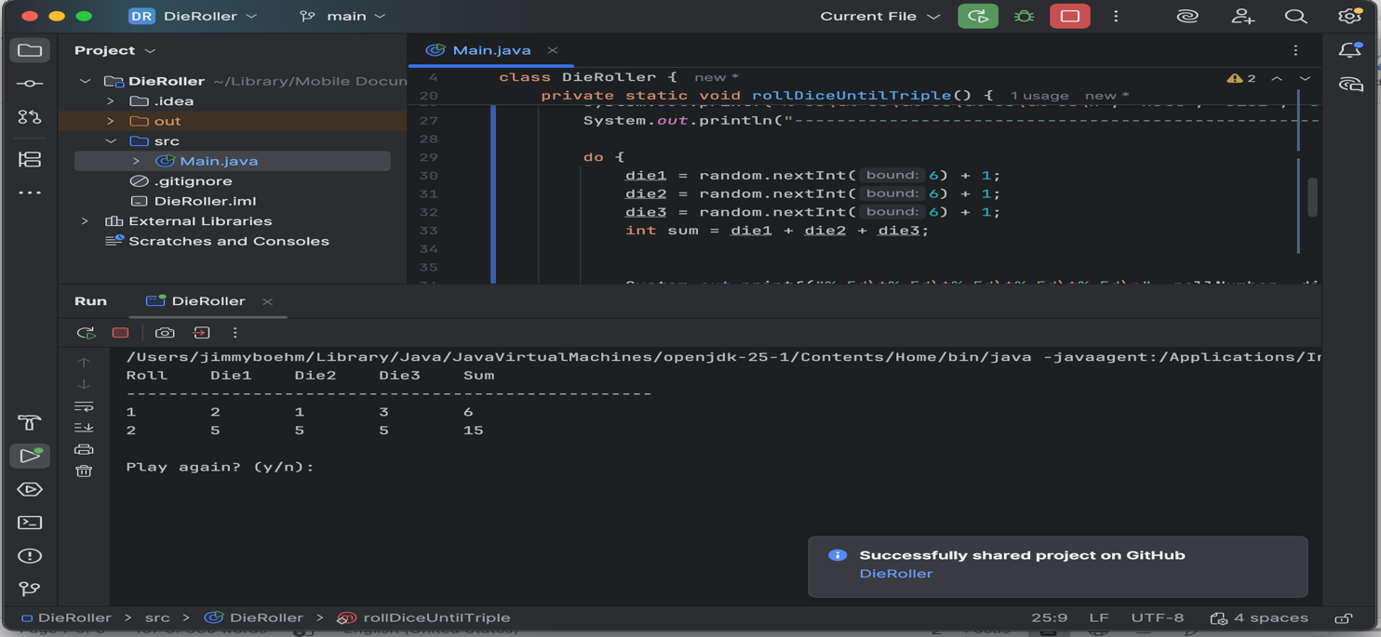
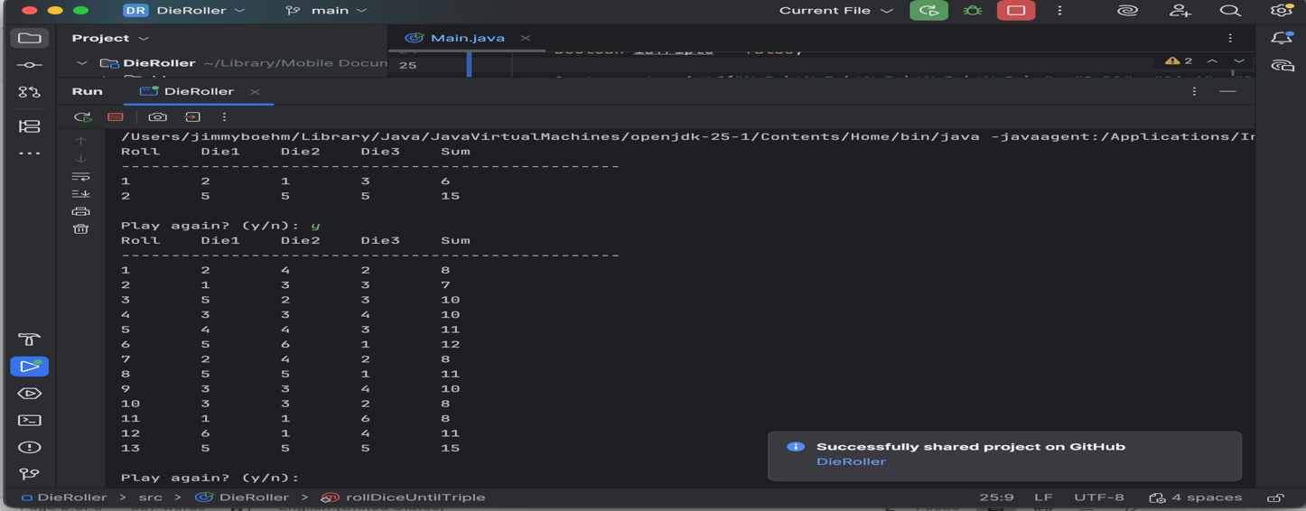
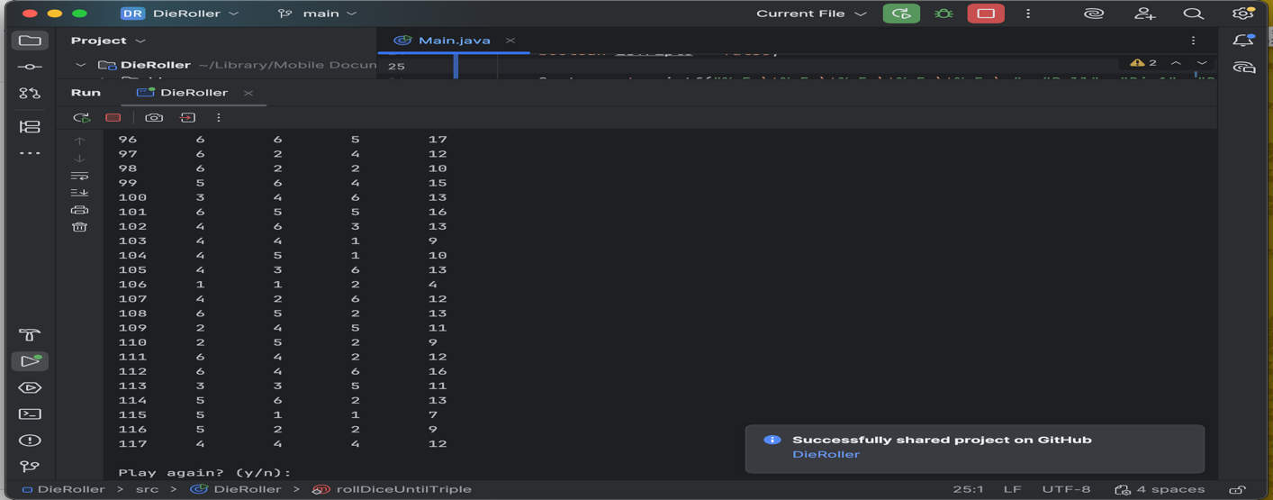

Post-Lab: Double-check Your Work
Now that you have completed the lab tasks, build constructive professional work habits by carefully rechecking your work, and abiding by the naming format and submission instructions.

Rename the file:
Use the YourLastname_YourFirstname_Lab07.docx format; remember to replace "YourLastname" and "YourFirstname" with your actual names.
The naming format will help us efficiently track and organize your files.

GitHub Link
Paste the link to your GitHub repo here.
https://github.com/boehmjs/GetLoopy

Submit
Submit to Canvas using the assignments mechanism to upload your document. Don’t submit a link to your document.

